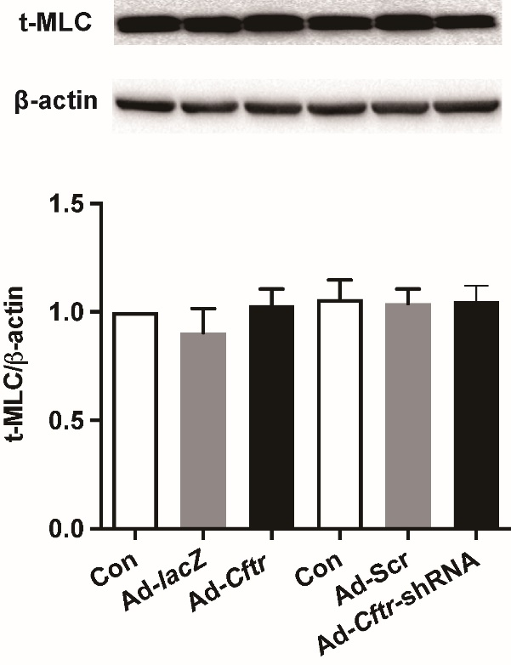
Supplementary Fig. 1. Effect of CFTR expression on the total myosin light chain (t-MLC) in BASMCs. BASMCs were treated with Ad-Cftr or Ad-Cftr-shRNA for 6h followed by cultivation with DMEM/F12 medium containing 10% FBS for another 48 h. Ad-lacZ and Ad-Scr were used as negative control, respectively. t-MLC in cell lysates were detected by western blot, no significant difference was observed (n = 6).
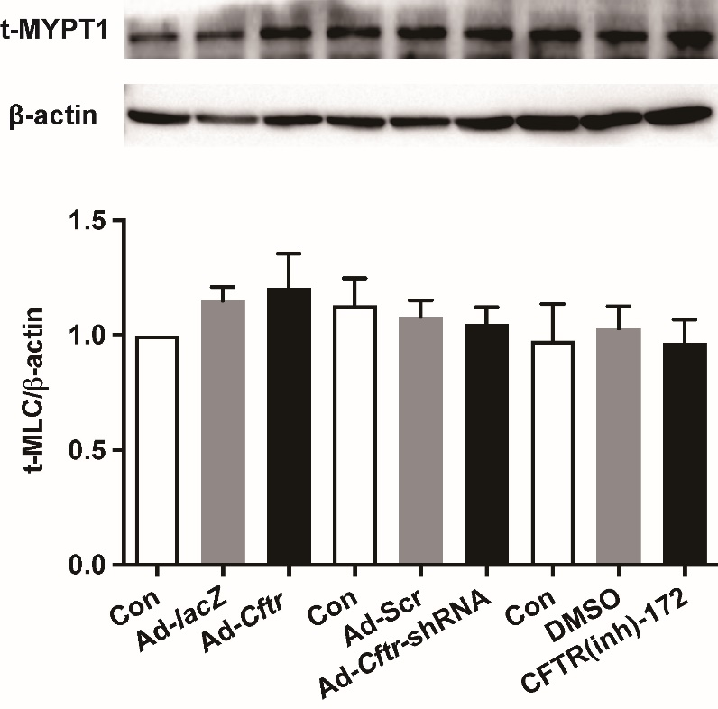
Supplementary Fig. 2. Effect of CFTR expression/activity on the total MYPT1 (t-MYPT1) in BASMCs. BASMCs were treated with Ad-Cftr, Ad-Cftr-shRNA, CFTR(inh)-172 (5 μM, 48 h) or the negative control vectors or solvent. Cell lysates were collected and total MYPT1 expression were detected using western blot, β-actin was used as loading control, no significant difference was observed (n = 6).

